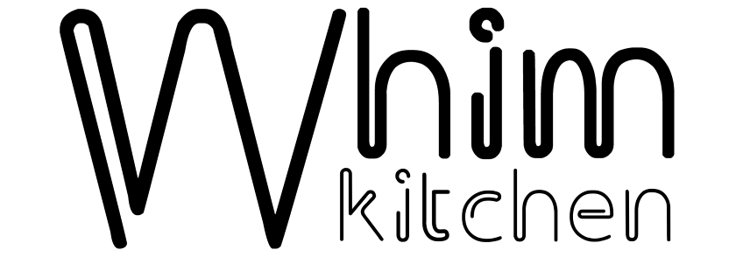

Whim Sando

We bake meat, cheese and other hot fillings into our homemade sourdough bread, and then finish with cold toppings.

Served with chips

Italian Style …………….. 12

ham, salami cotto, soppressata, provolone, sweet onion, pickled peppers, shredded lettuce, aioli\*,

red wine vinaigrette

Smoked Turkey ………… 11

mushroom, gruyere, kale, celery, carrots, red onion, craisins, buttermilk herb dressing\*

Mushroom ..……...………10

roasted mushrooms, gruyere, greens, pickled onions, avocado, lemon sesame dressing\*

Bolsillo

Folded baked bread with hot fillings

Pumpkin “Chorizo” ……… 7

muenster cheese, cabbage

Ham and Cheese ...……….. 7

cheddar, provolone, monterey jack

Soups & Salad

Dressing choices: lemon sesame dressing\*, red wine vinaigrette, roasted shallot vinaigrette, buttermilk herb dressing\*

House Salad …………. side 2.50/regular 6

mixed greens, carrots, radish, red onion, choice of dressing

Kale Salad …..……….. small 4/regular 8

roasted delicata squash, turnips, celery, fennel, mushrooms, roasted shallot vinaigrette

Soup of Whim ……... cup 3/bowl 6

Snacks

Bag o’ Chips … 1.50 Spanish Tortilla …. half 3/full 6 Pickle Plate ….5

Charcuterie …… 18 Pickled Egg ….. 2.50 1 oz Charcuterie …… 5

Smoked Carrot Dip w/Flatbread …… 6

\*Consuming raw or undercooked meats, poultry, seafood, shellfish, or eggs may increase your risk of foodborne illness

Menu Subject to Change on a Whim